

Med services for IT Governance

**Cyber Security Audit reported by mohamed oueslati:**



**Cyber Security Audit Report**

**Prepared for**

**steroids shop**

CSA Sample Report Copyright © IT Governance Ltd 2017 Page 2 of 6

**Table of Contents**

1.0 Executive summary 4

2.0 Cyber Assessment Summary Recommendations 4

3.0 Conclusion 6

# 1.0 Executive summary

Med services for IT Governance was invited to conduct a cyber security audit prepared by mohamed oueslati and review steroids shop’s office in Menzah 5 on the 12th December 2022. **The purpose of the audit was to determine whether the steroids shop is qualified to continue serving its customers or not.**

# Cyber Assessment Summary Recommendations

**1*SSL or TLS certificate:**

**Yes, more details:**

Émis le

lundi 7 novembre 2022 à 05:06:02

Expire le

dimanche 5 février 2023 à 05:06:01

Empreinte SHA-256

4C 77 4C A3 50 85 B5 3F B8 6E 7C 5F 9F 87 65 0E 07 1D A3 A4 DC B4 D7 F3 44 FE E6 91 BA E9 80 C6

Empreinte SHA-1

7B F5 39 C5 87 C7 02 97 17 85 93 1C B6 F4 DE 8D 7A 59 D6 F2

**2*Cloud Metadata secured:**

**No, more details:**

NGINX is reachable by any ip address (lack of a FW)

**3*Encrypted data:**

**No, more details:**

a response contains Personally Identifiable Information, such as CC number, SSN and similar sensitive data.

( Credit Card Type detected: Maestro

Bank Identification Number: 675273

Brand: MAESTRO

**4*uptaded Libraries:**

**No, more details:**

                 Vulnerable JS Library was detected (Jquery)

**5*Anti-clickjacking measurments:**

**No, more details:**

 Missing Anti-clickjacking Header were not found

**6* internal systems secured (physical security network):**

**no, more details:**

Hidden File Found due to an exposure to internal systems or specific source Ips.

# 3.0 Conclusion

The Tunisian government’s [National Security Strategy a](http://www.direct.gov.uk/prod_consum_dg/groups/dg_digitalassets/@dg/@en/documents/digitalasset/dg_191639.pdf)cknowledges cyber threats as one of the four major risks to national security. **steroids shop did not complie to multiple rules wich may** cause a data breach that will affect Hundreds of customer accounts.

For more information on how Med services for IT Governance can help you establish a solid IT security foundation with our [**Cyber Security Audit**,](https://www.itgovernance.co.uk/cyber-security-audit) please the following address email : **MedforITGovernance@med.tn**.



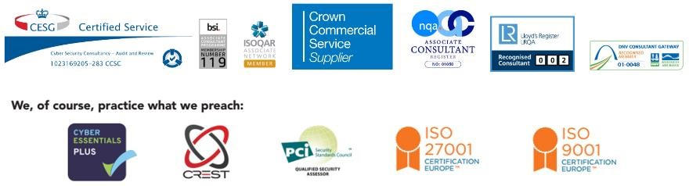

(Disclaimer: The report is based on a real-life consultancy project carried out by IT Governance Ltd. Names have been changed to protect the identity of the clients.)